**This is a practice worksheet for Demand and supply. Notice that some of the questions do not have solutions. Try them out on your own, and if you run into problems, feel free to ask the student tutors for help. Best of luck!**

**Demand and Supply**

**Q1)** Given the following observations:

| Price/Cartons of Coke | Quantity Demanded  (Millions of Cartons) | Quantity Supplied (Millions of Cartons) |
| --- | --- | --- |
| 6 | 1 | 11 |
| 5 | 3 | 8 |
| 4 | 5 | 5 |
| 3 | 7 | 2 |
| 2 | 9 | 0 |
| 1 | 11 | 0 |

(a) Label the vertical axis as the price per unit of Coke and the horizontal axis as the quantity of the Coke per month.

Draw the demand curve and label it D.

Draw the supply curve and label it S.

Label the price where the quantity demanded equals the quantity supplied as P* and the corresponding quantity as Q*. What does this point mean?

(b) Choose a price above the equilibrium price and label it P1. Is there a surplus or shortage? What is its size?

(c) Choose a price below the equilibrium price and label it P2. Is there a surplus or shortage? What is its size?

(d) Note that in a price system without government interference the condition of surplus or shortage drawn above is only temporary. After a trial-and-error period of time the forces of surplus and shortage will automatically restore the equilibrium price and quantity as originally drawn in step one. Explain how this occurs.

**Q1 Solutions**



b)



There is a surplus since quantity supplied is higher than quantity demanded. There is a surplus of 5 goods

c)



There is a shortage of 5 goods since the quantity demanded is greater than quantity supplied.

d) In the face of a surplus, sellers are likely to reduce their prices. As the price lowers, there will be a decrease in the quantity supplied (but not a change in supply) and an increase in the quantity demanded (but not a change in demand) until the equilibrium price is achieved.

In the face of a shortage, sellers are likely to begin to raise their prices. As the price rises, there will be an increase in the quantity supplied (but not a change in supply) and a reduction in the quantity demanded (but not a change in demand) until the equilibrium price is achieved

.

**Q2)** Use the demand and supply framework to qualitatively analyze the market in each of the scenarios given in part a to d.

How would the demand and/or supply curves shift? (Leftward/rightward/no shift)

What are the effects on equilibrium price and quantity? (Increase/decrease/ambiguous)

**Summarize the result in the following table format:**

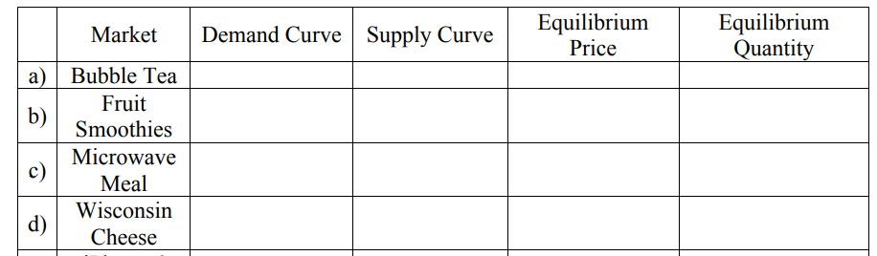

**Show all the shifts and changes in equilibrium prices and quantities using separate diagrams.**

a) A recent study claims that the tapioca pearls in bubble tea are linked to increased risk for cancer, creating fear among consumers.

b) In addition to the study report in a), you are also told that fruit smoothies are good alternatives to bubble tea. At the same time, you know that the extended summer has invigorated fruit harvests.

c) Teaching assistants consider microwaveable meals an inferior good. This semester, they are greeted with bad news as the Department of Economics cuts their stipends by 15%.

d) Wisconsin produces fine cheese using cow's milk; however, mad cow disease has wiped out half the population of cows in Wisconsin.

**Q2 Solution**

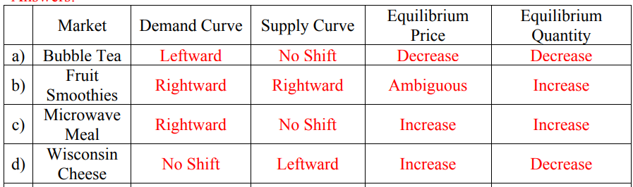

**Q3)**  Given the following information:

*Qd = 100 - 5P*

*Qs = -125 + 20P*

where Qs: Quantity supplied & Qd: Quantity demanded

1. Find the market equilibrium price(P) at which there will be no excess or surplus in the market.

**Q4)** Given the followinginformation:

Qs = 5 + 4P

Qd = 9 + 3P

where Qs: Quantity supplied & Qd: Quantity demanded

1. (a) Find the market equilibrium price(P) at which there will be no excess or surplus in the market.
2. At P=6, calculate the shortage/surplus.

**Q5)** What is the effect on the price of a camera lens and the quantity of camera lens sold if:

a. The price of a camera rises? - decrese qd

b. The price of a camera falls?- increase qd

c. The supply of camera lenses increases? - p increase

d. Consumer's income decreases? - dem- decrease

e. The wage rate of workers who produce camera lenses increases? - s decrease

f. The wage rate of workers who produce camera lenses increases at the same time the price of a camera falls. The effect of increasing the wage rate is higher than the effect of falling camera prices. - d right s-left

**Q6)** Suppose that the market demand for potatoes is given by *Q = 1000 – 250P* and the market supply of potatoes is given by *Q = 150P,* where P is the price per bag of potatoes and Q is the number of bags per month. What is the equilibrium price and quantity for potatoes? Illustrate your answer graphically.

**Q7)** The demand and supply schedules for broccoli are given in the following tables. Use this information to answer the questions below:

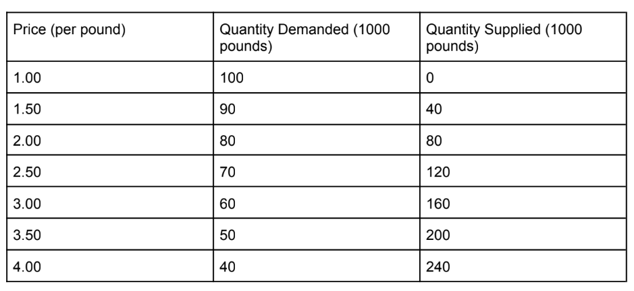

a. What is the equilibrium price and quantity in the broccoli market? Illustrate your answer graphically.

b. Explain why the market will be in disequilibrium at a price of $3.50 per pound

c. Explain how the market will adjust from a price of $3.50 per pound to the equilibrium identified in part (a).

**Q8)** Assume that the markets for sugar cane, rum, and whiskey are initially in equilibrium. Assume further that Hurricane Marilyn destroys much of the Jamaican sugar cane crop. Sugar cane is a principal ingredient in rum, but it is not an ingredient in whiskey. Analyze the effect of the hurricane on the markets for each of the three goods. Explain using graphs.

**\*\*Q9**. Consider the substitute goods, coke and pepsi, you are given the demand and supply functions of pepsi as follows:

*Qd=5.6PC-3PP*

*Qs=13+6PP+0.2PC*

Here, PC is the price of coke and PP is the price of pepsi.

a. If the price of coke is $8, what is the market price and quantity of pepsi?

b. If the price of pepsi is fixed at $7 by the government, what would the shortage/surplus amount?

**Q10.**  A perfectly competitive market consists of 15 individual buyers and 10 individual sellers. Each buyer’s inverse demand curve is given by

*p= 20−(⅕)q.*

Each individual supplier’s inverse supply curve is given by

*p=(⅕)q−2.*

1. Find the equilibrium price and quantity.
2. At P=12, will there be a shortage or surplus? Calculate it.
3. At price=5, will there be a shortage or surplus? Calculate it.

**MCQs**

1. John wants a car worth $1m, but he does not have the ability to buy it. Can we say that John demands the car?
2. Yes
3. **No**
4. According to the law of demand what kind of relationship does the price of a commodity and the quantity demanded exhibit?
5. Positive relationship
6. **Inverse relationship**
7. No relationship
8. Can't be generally determined
9. A movement along the demand curve of cars will occur due to :
10. Changes in population
11. Changes in income
12. **Changes in price of cars**
13. Changes in price of fuel
14. A shift in the demand curve for apples to the RIGHT may occur due to:
15. **Increase in the price of oranges**
16. Increase in the price of apples
17. Decrease in population
18. Decrease in the price of apples

*Hint: think of substitute products*

1. A shift in the demand curve for cars to the LEFT may occur due to:
2. Increase in the price of apples
3. Increase in the price of cars
4. **Increase in the price of fuel**
5. Decrease in the price of fuel

Hint: think of the complementary goods

6. If John's income increases, what kind of goods would he demand more?

1. Complementary goods
2. **Normal goods**
3. Inferior goods
4. Substitutes

7. If John's income decreases, what kind of goods would he demand more?

1. Normal goods
2. **Inferior goods**
3. Substitutes
4. Complementary goods

8. If it is expected that the Government will cut down VAT on laptops in the near future, what will happen to the demand for laptops today?

1. Demand will increase and demand curve will shift to the right
2. **Demand will decrease and demand curve will shift to the left**
3. Demand will remain unchanged
4. Demand will decrease and demand curve will shift to the right

9. If birth rates increased significantly, what is expected to happen to the demand for childcare services(ceteris paribus)?

1. **Demand for childcare services will increase and demand curve will shift to the right**
2. Demand for childcare services will decrease and demand curve will shift to the right
3. Demand for childcare services will increase and demand curve will shift to the left
4. Demand for childcare services will decrease and demand curve will shift to the left

10. If a society becomes more weight conscious, what is likely to happen to the demand for normal coke and diet coke respectively?

1. Decrease, decrease
2. **Decrease, increase**
3. Increase, increase
4. Increase, decrease

11. According to the law of supply, what kind of a relationship does the price of a commodity and the quantity supplied exhibit?

1. Negative relationship
2. **Positive relationship**
3. No relationship

12. If the government removes subsidies from the agricultural sector, what would happen to the supply of agricultural goods?

1. Will increase and there will be a shift of the supply curve to the right
2. **Will decrease and there will be a shift in the supply curve to the left**
3. Supply will be unaffected
4. Supply will decrease and there will be a shift in the supply curve to the right

13. If the price of oil per litre is **expected** to increase further, what is likely to happen to the supply curve now?

1. Shift to the right
2. **Shift to the left**
3. Remain unchanged

14. If there is a new invention that enables the production of a commodity with less time and labor than before, what is likely to happen to the supply of that commodity?

1. **Supply will increase, supply curve will shift to right**
2. Supply will increase, supply curve will shift to the left
3. Supply will decrease, supply curve will shift to the left
4. Supply will decrease, supply curve will shift to the right

15. Apple market equilibrium price is the price at which:

1. Quantity demanded of apples is greater than quantity supplied
2. **Quantity demanded of apples is equal to the quantity supplied**
3. Quantity supplied of apples is greater than quantity demanded

16. Demand curve for diet coke shifted to the right, what will happen to the market equilibrium price of diet coke and quantity demanded respectively?

1. Increase, decrease
2. In**crease, increase**
3. Decrease, decrease
4. Decrease, increase

17. If a flash flood occurs, what is likely to happen to the supply curve and the market equilibrium price?

1. Shift to the right, Increase
2. **Shift to the left, increase**
3. Shift to the right, decrease
4. Shift to the left, decrease

18. Price of diesel increased, what is likely to happen to the food supply and the market equilibrium price?

1. Supply curve will shift to the left, price will increase
2. Supply curve will shift to the right, price will decrease
3. Supply curve will shift to the left, price will decrease
4. **Supply curve will shift to the right, prove will decrease**

19. The price of **Beef** rose to 500tk per kg from 350Tk per kg. What will be the effect on demand for **chicken**, the quantity demanded of chicken and the market equilibrium price for chicken (ceteris paribus)?

1. Shift to the left, decrease, increase
2. S**hift to the right, incr**ease, increase
3. Shift to the left, decrease, increase
4. Shift to the right, decrease, decrease

20. If the supply curve shifts to the right, what will be the effect on Quantity supplied and market equilibrium price of X?

1. Increase, increase
2. Decrease, decrease
3. Decrease, increase
4. **Increase, decrease**

21. If the demand for laptops increases and the demand curve shifts to the right, at the same time supply increases and shifts to the left, what will be the effect on the equilibrium market price?

1. May increase
2. May decrease
3. **May remain unchanged**
4. All of the above

22. If the demand for transportation services increases and the supply for transportation services decreases, what will be the effect on the market equilibrium price and quantity?

1. Will Increase, will decrease
2. Will Increase, will increase
3. **Price Will Increase, quantity may remain unchanged**
4. Will decrease, may remain unchanged

23. If the demand for milk decreases and the supply of milk increases, what will be the effect on the equilibrium price and quantity?

1. Decrease, will be higher
2. Increase, will be lower
3. De**crease, maybe unchanged**
4. Increase, may be higher

24. If the demand for iPhone X falls and the supply of iPhone X also falls, what will be the effect on equilibrium price and quantity?

1. Fall, will fall
2. Pri**ce may increase or decrease or remain the same and quantity will fall**
3. Increase, will increase
4. Increase, may increase, decrease or remain the same